THEVENIN’S THEOREM
STEP I – To Find Vth
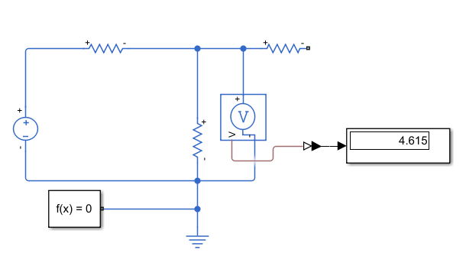
STEP 2 – To Find RTH (RTH = V / I)
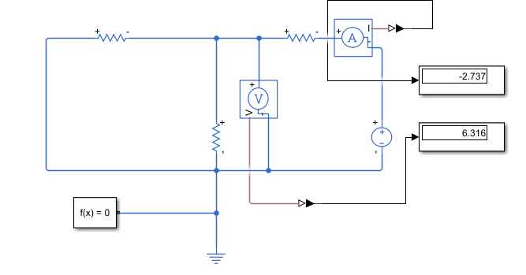
STEP 3 – To Find the load current (IL)
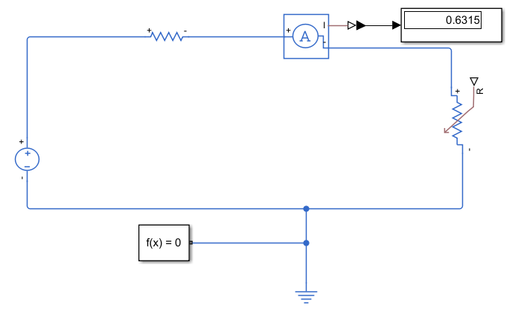

THEVENIN’S THEOREM
STEP I – To Find Vth
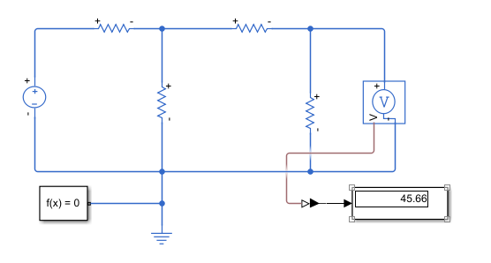
STEP 2 – To Find RTH (RTH = V / I)
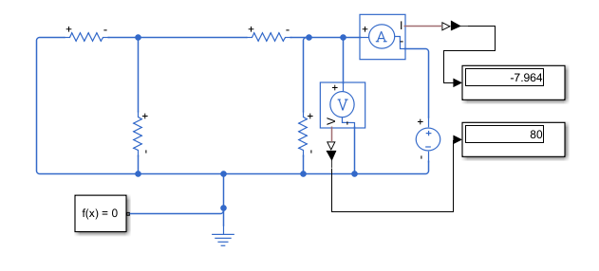
STEP 3 – To Find the load current (IL)
